
Best score for me!

- Copy this line of fraction cards.
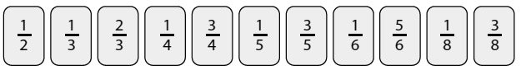
- Choose a fraction, e.g.
- Look at the number grid below.
- Find two numbers, which, one over the other, make an equivalent fraction to the one chosen, e.g.
- Write the equivalent fraction below the fraction card.
- Cross out these two numbers on the grid.
- Choose another fraction and repeat, e.g. choose , write and cross out 4 and 20.
- Keep going like this. You cannot use a crossed-out number on your grid for a second time!
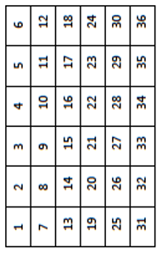
- For how many fraction cards did you manage to write equivalent fractions underneath? A good score is anything over 6, but you are chasing 9 or 10!

What sort of fractions is it best to choose first? Why?
Why is it not sensible to choose first?
Which numbers on the square are never used?



