

CROWTHORNE CHURCH OF ENGLAND

PRIMARY SCHOOL

SEND Information Report
Status of Report | Date
Reviewed | Annually

Ratified by governors

Review date:

Our school policies and reports reflect our vision of:

Inspiring and enabling our school community to live life to the full,
promoting excellence and nurturing compassion, honesty, trust, hope,
respect, thankfulness and courage.

John 10 v 10:
Jesus said: “I have come that they might have life, and have it to the full”

SEND Governor: Brioney Moore
SENDCo: Caroline Parker
Address: Dukes Ride
Crowthorne
Bershire, RG45 6ND
Tel: (01344) 772089
Email: secretary@crowthornecofe.co.uk
Website: https://www.crowthornecofe.co.uk/

Introduction

All Bracknell Forest schools are supported by the Local Authority to be as inclusive as possible of all children, including those with Special Educational Needs and Disabilities (SEND), ensuring that all children make the best possible progress.
What is the Local Offer?
• As a result of The Children’s and Families Bill 2014, Local Authorities and schools are required to publish and keep under review information about services they expect to be available for the children and young people with Special Educational Needs and Disabilities (SEND) aged 0-25. This is the Local Offer.
• The intention of the Local Offer is to improve the choice and transparency for
families. It is also an important resource for parents/cares in understanding the
range of services and provision in the local area.
• Bracknell Forest’s Local Offer can be found by clicking on the following link:

https://bracknellforest.fsd.org.uk/kb5/bracknell/directory/localoffer.page?localofferchannel=0

With reference to the Local Offer the SEN information Report outlines how we as a school meet the provision set out in our school SEND Policy. This policy can be found on our school website on the SEN page.

The School SEND Information Report
At Crowthorne, we have a 'lift the lid culture'. We strongly believe that every child, including those with special educational needs, should be given the opportunity to reach their full potential and are well-prepared for the next stage in their learning journey.

At Crowthorne C of E School, we aim to:

- Identify needs early and adopt a graduated response to meeting these in line with the 2014 SEN Code of Practice (DfES 2014)
- Work in collaboration with parents to achieve the best outcomes for our children.
- Be fully inclusive and meet the needs of every child in the most appropriate way.
- Provide high quality teaching and learning experiences for pupils with SEND.
- Work effectively with external agencies to provide the right support at the right time our pupils.

In the report that follows, we give more information about how we aim to support your child and you during their time with us.

1. How does Crowthorne C of E School identify children with special educational needs and disabilities?
As children join Crowthorne C of E, whether via Reception or by transferring from another primary school, we liaise with previous settings to identify any already known needs or concerns (this includes meeting with key workers form the CDC-Child Development Centre). Where a need is identified, the SENCo will visit the child, and staff, in their current setting.

Throughout a child’s school life, a range of evidence is collected through the usual assessment and monitoring arrangements, backed up by termly Pupil Progress Meetings and SENCO Surgery meetings. If it becomes clear that a child
is failing to make appropriate progress, additional support will be provided.
Underpinning ALL our provision in school is the graduated approach cycle of assess, plan, do, review:

The Graduated Approach
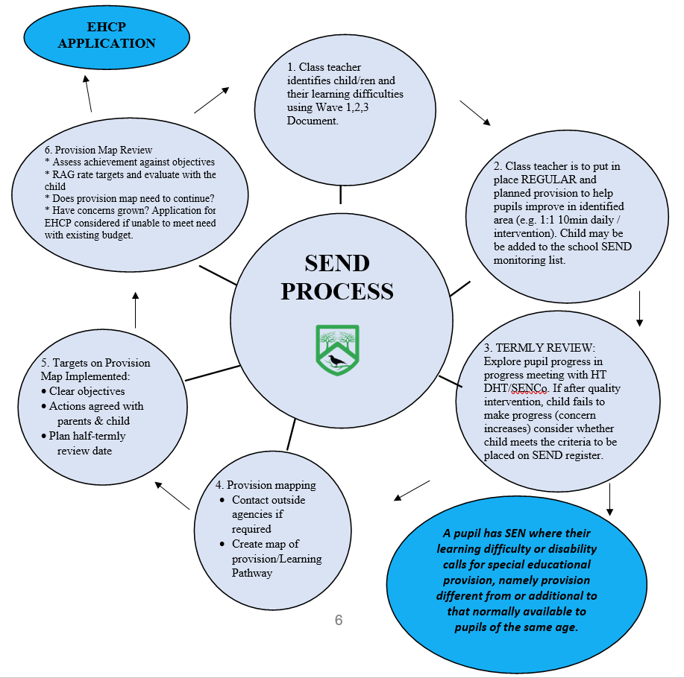

Pupils are considered to have additional needs and are named on our SEND register if:
- They have an Education Health Care Plan;
- They have a diagnosis that would affect learning/access to the curriculum, including medical diagnoses;
- They have current or recent (last 12 months or within last academic year) involvement with an outside agency and require longer term provision to meet need and make progress.
- They have a learning difficulty or disability which calls for special education provision to be made for him or her;
- They require provision over and above high quality first teaching.

The SENCo keeps a SEND Monitoring List which includes the names of children who have been brought to the attention of the SENCo (by a Teacher or parent) as potentially needing to be added to the SEND register. This information is shared with individual Class Teachers at the beginning of the school year, and when there are any changes to the list.
If it is felt the above criteria is met, the parent(s)/carers are invited to a meeting with the SENCo. Within the meeting, there will be a discussion about whether the child will be placed on the monitoring list or the SEND register.
In the meeting:
• There will be a discussion about the child’s strengths and ‘weaknesses’ and whether the need falls under one or more of the following categories (4 main areas of need):
- Cognition and Learning
- Speech and Language and Communication
- Social /emotional or
- Sensory and/or Physical.
• Staff will explain the SEND register and monitoring list and how this supports the school in meeting needs identified.
• Each stage of the graduated response will be explained to parents.
• Parents/Carers will be signposted to the SEND section of the school website which includes the school SEND policy, Local Offer and SEND Information Report.
• The Teacher will set up a Learning Pathway (sometimes referred to as a Provision Map or IEP) with targets related to the child’s area of need. Targets will be worked on in school and resources (where relevant) sent home for parents to support. The targets will be reviewed at the end of each half term with the child and new targets will be set; one of these targets will be chosen by the child. Parents are invited to contribute towards the evaluation of, and setting of targets.
• If a referral to an outside agency is needed, this will also be discussed in the meeting.
• Pupils can be taken off of the register if they no longer fulfil the criteria.
• Parents/Carers will be invited to half termly SENCo surgeries, as well as termly parents’ evenings.
• Parents/Carers will be given information about the Local Offer (Bracknell or Wokingham as appropriate) and the Information, Advice and Support Service (IASS):
https://www.bracknell-forest.gov.uk/children-and-family-services/special-educational-needs-and-disability/send-local-offer
https://can-do.bracknell-forest.gov.uk/Graduatedapproach2024
https://www.wokingham.gov.uk/children-families-and-young-people/send-local-offer
• Parents/Carers will receive formal notification via a letter when the decision is made to place their child on the SEND register, and they will receive a copy of their child’s Learning Pathways each half term.
Children with Educational Health Care Plans also have a statutory annual review with parents/carers, the local authority and relevant professionals involved.

2. Who to talk to if you are worried about your child
Talk initially to your child’s class teacher- All teachers are responsible for every child in their care, including those with special educational needs.
Teachers are responsible for:
• Checking on the progress of your child and identifying, and planning any additional help they may need and letting the school’s SENCo know where necessary.
• Writing targets for Individual Learning Pathways, sharing and reviewing these each half term with children, parents/carers, and outside professionals (if involved) and planning for the next steps.
• Ensuring the SEND Policy is followed in their classroom for all the children they teach with any SEND.
Plan to meet again with the Class Teacher at an agreed later date to revisit your concerns and discuss any progress that has been made. If there has been little improvement, then the Class Teacher will refer you on to the school’s SENCo.

The SENCo is responsible for:
• Developing and reviewing the school’s SEND Policy.
• Coordinating all the support for children with special educational needs or disabilities (SEND).
• Ensuring that you are:
1) Involved in supporting your child’s learning.
2) Kept informed about the support your child is getting.
3) Involved in reviewing how they are doing.
• Liaising with all outside professionals who may be coming into school to help support your child’s learning, e.g. Speech and Language therapy, Behaviour Support Team, Educational Psychologist, Support for Learning, Autism Team.
• Updating the school’s SEND register (a system for ensuring all the SEND needs of children in this school are known) and making sure that records of your child’s progress and needs are kept.
• Providing specialist support for teachers and support staff in school, so that they can help children with SEND to achieve the best possible progress.

Other people you can talk to:
The Head Teacher: Mrs Emily Hicks
The School ELSA (Emotional Literacy Support Assistant): Mrs Jo Bradley
The SEND Governor: Mrs Brioney Moore

The Head Teacher is responsible for:
• The day-to-day management of the school; this includes the support for children with SEND.
• The Head Teacher will give responsibility to the SENCo and Class Teachers, but is still responsible for ensuring that your child’s needs are met.
• The Head Teacher must make sure that the Governing Body are kept up to date about information relating to SEND.

The School ELSA is responsible for:
- Helping children learn to understand their emotions and respect the feelings of those around them.
- Providing time and space for pupils to think about their personal circumstances and how they manage them.

The Governing Body is responsible for:
• Making sure the necessary support is given for any child with SEND who attends
the school.

3. How parents/carers are kept informed/consulted about the ways in which their child is being supported
Involving parents and ensuring that they are informed about any support given to their child is central to our approach and we do this through:
Action/Event | Who is involved | Frequency
Open door policy | Class Teacher in the first instance | As and when required by appointment during term time.
SENCo Surgeries | Parents are offered an appointment every half term, before Learning Pathway Targets are reviewed to meet with the school SENCO. The SENCo feeds back what was discussed in the meeting, and any related actions to the Class Teacher. | Half termly
Sharing and Reviewing Targets | SENCo at SENCo Surgery meetings  Teacher  Teacher sends home evaluated and new targets. Parents are provided with the opportunity to contact the Teacher if they would like to discuss the targets. | Half Termly  Twice a year at Parents Evening  Half termly
EHCP Reviews | SENCo, Class Teacher, parent/carer, child and other relevant professionals (including a representative from the LA SEND team for transition reviews). | Annually

The 2014 SEN Code of Practice (DfES 2014) recognises 4 broad categories of need:
1. Communication and interaction
2. Cognition and learning
3. Social, emotional and mental health
4. Sensory and/or physical needs

At Crowthorne C of E we, like the Code of Practice, recognise that children’s needs and requirements may fall within or across these categories and that their needs may well change over time.
Our aim always, is to meet your child’s needs as and when they occur, in whichever category or categories they fall.
At Crowthorne C of E Primary School, all Teachers and Support staff are teachers of SEND. Pupils are well planned for and well supported and there is a balance between support and independent work. SEND pupils are taught alongside their peers in the classroom and sometimes split inputs are provided.
The vast majority of children with SEND work on their year group objectives with activities that are differentiated to meet their needs. Gaps from previous year group’s objectives are plugged through careful planning, interventions and Learning Pathway targets. For some children with more complex needs- who are unable to access their chronological year group objectives- teachers may plan a separate curriculum based on earlier year group objectives.
The table below outlines the current specific intervention programmes available to children with SEND. However, this does not show the bespoke programmes designed for individual children as needs arise throughout the year.

Type/Title of Intervention | One to one | Small group
Speech and Language (SALT)
Occupational Therapy- Fine and Gross motor skills
Support for Learning
ELSA (Emotional Literacy Support Assistant)
Specific Phonics Intervention
Pre- Teaching
Precision Teaching
Reading Fluency Intervention
Reciprocal Reading Intervention
Maths Intervention
Spelling Intervention
Typing Skills

Along with these specific Intervention Programmes, and bespoke individual programmes, we also offer group work intervention run by either a Learning Support Assistant or Class Teacher. These will be for children identified by the Class Teacher as requiring additional support in a particular area and will take place both in and out of the classroom.

5. The equipment and resources the school provides for children with SEND
We resource and provide equipment to support the child’s individual needs.
For example:
• Resources such as standing desks and writing slopes are available if your child is assessed as needing these and may help a child experiencing difficulties in reading and writing related tasks.
• Individual visual timetables are often used along with “Now and Next” boards which break down the day further into the immediate and next task to be completed. Zones of Regulation charts may be used to support children in identifying their emotions and are supported in using self-regulation strategies.
• “Fiddles”, timers and “move ‘n’ sit” cushions and ear defenders may be found to be a useful aid. Movement breaks are also provided for children who require brain breaks.

Teaching Assistants
All classes have access to a Teaching Assistant for the majority of the week.
If your child has an Education Health Care Plan, they may also receive additional learning support, however pupils do not have assigned Teaching Assistants who are with them all day. Adults may support pupils individually, with whole class learning or run small groups including your child.

6. How we monitor your child’s progress
As part of quality first teaching (day-to-day excellent targeted classroom teaching) your child’s progress will be continually monitored by his/her Class Teacher.
The table below sets out the monitoring that can be expected to take place for a SEND child at Crowthorne C of E.
Progress Monitoring | Who is Involved | Frequency
Pupil Progress Meetings | Class Teacher, Head Teacher, Deputy Head Teacher, SENCo | Termly
Sharing and Review of Targets | Class Teacher, SENCo, Parent/Carer and child | Half termly
SENCo Surgeries (parents) to discuss progress and Learning Pathway. | SENCO, Parent/Carer | Half termly
SENCo Surgeries (teachers) to discuss progress and Learning Pathway. | SENCo/Teacher | Half termly
Inclusion Team Meetings | Head Teacher/ Deputy Head Teacher/SENCo and School ELSA | Fortnightly
Book looks and planning looks, lesson drop-ins, pupil conferencing | SENCo/Head Teacher/senior leadership team/subject leaders, Teachers | Throughout the year
EHCP Reviews | SENCo, Class Teacher, Parent/Carer, child and other relevant professionals (including a representative from the LA SEND team for transition reviews). | Annually
Outside Professional Assessments | Outside professional, SENCo, Class Teacher, Parent and child (if appropriate)

As progress is reviewed, new targets may be set. Within this process, the child, their parents and any appropriate professionals are consulted. Outside of these more formal reporting arrangements, you are of course always welcome to come and discuss your child’s progress with school staff.

7. How you can help support your child’s learning
At Crowthorne C of E, we believe that the education of any child is a partnership between the school, parents and child. As parents, we want you to be active participants of the ‘Assess, Plan, Review, Do’ cycle for your SEND child. Good communication at all times between school and home is the key to ensuring the best possible outcomes for your child. There are also a number of other sources from which parents/carers may find help to enable them to support their child’s learning:

Support for Parents | Who is Involved | Frequency
School Website  The SEND page of the website includes links to outside agencies who provide additional advice and support | School staff, Governors, Parents/Carers and child | To all parents, open access
School Newsletter | School staff, Governors, Parents/Carers and child | Fortnightly
Open Door Policy | Class Teacher in the first instant | As and when required by appointment, during term time
Mental Health Lead | SENCo/Deputy Head Teacher, Parents/Carers | As and when required by appointment, during term time
ELSA | ELSA, Parents/Carers | As and when required by appointment, during term time
External Agency advice/support | School staff, Parents/Carers and relevant external providers | As and when required by appointment, during term time

8. How we make sure that the voice of the SEND child is heard
It is vitally important that at every stage the child has the opportunity to tell us how they think the support they are being given is helping them, how they feel they are progressing, and if there is anything they would like to see change.
The table below outlines the main opportunities which are given to ensure that this happens.
Child Views | Who is Involved | Frequency
In Class Dialogue | Class Teacher, Teaching Assistant, child | Regular- embedded as part of quality first teaching
Sharing and Reviewing of Targets | Class Teacher/Teaching Assistant and child | Half termly in class
Pupil Conferencing | SENCo and child(ren) | Annually
Topic Talks | Subject Lead and child(ren) | Termly
EHCP Reviews | SENCo, Class Teacher, Parent/Carer, child and other relevant professionals | Annually

9. How Crowthorne C of E school assesses the overall effectiveness of our SEND provision and how parents / carers and children with SEND can take part in this evaluation
• Historic data analysis is regularly reviewed using the school's data, alongside monitoring and tracking of school data.
• The views of parents/carers and the child are actively sought during consultation meetings, as well as SEND Education Health and Care plan annual reviews. The SENCo sends out a parent survey bi-annually.
• The SENCo regularly meets with the Head Teacher, Teachers, Learning Support Assistants and outside agencies to discuss the progress of children.
• Termly progress meetings look at the effectiveness of SEND provision.
• The school Governors provide an additional layer of quality assurance, ensuring evaluation.

10. The support available for your SEND child’s overall well-being and their family
• As part of quality first teaching, we offer all children a rich and diverse curriculum, which incorporates PSHCE and pastoral support.
• The Teachers, Teaching Assistants and the School ELSA work with pupils who have identified social and emotional needs through 1:1 and/or group work.
• We also work closely with external agencies to support children who may require additional social and emotional and mental health support, such as the Mental Health Support Team (MHST), SEMH/Inclusion Team, Child and Adolescent Mental Health Service (CAMHS) and Autistic Spectrum Support Service.
If a child has personal care needs, we would consult with the child’s parents/carers, social services and relevant medical professionals to produce a Personal Care Plan to ensure adequate provision for that child. (Please also refer to our Intimate Care Policy)
• Where a SEND child is also a looked after child (CLA), close liaison is kept with the child’s carers, the designated Teacher from the Virtual School and the Social Care Services involved with their care.

11. The kinds of specialist services and expertise available at or accessed by the school
Specialist Services
- Autistic Spectrum Social Communication (ASSC)
- Support for Learning
- Behaviour Support Team
- SEMH/Inclusion Team
- Child and Adolescent Mental Health Service (CAMHS)
- SEND advisor
- School nurse
- Specialist Nurses (E.g. Epilepsy Nurse/Diabetic Nurse)
- Children and Young People Integrated Therapy service (CYPIT)
- Speech & Language (SALT)
- Occupational Therapy (OT)
- Physiotherapy (PT)
- Sensory Consortium
- Educational Psychologist service (EPS)
- Social Care
- Family Intervention Team (FIT)
- Mental Health Support Team (MHST)
- Early Help

Involvement from any of the above outside agencies comes as a result of on-going concerns regarding your child and quality first teaching and interventions not resulting in the expected improvements and progress. At this point, your views would again be sought and discussions had as to the best way forward and next steps to take.
If you feel that your child needs support from one of these services, in the first instance, discuss your concerns with the Class Teacher, who will then as appropriate refer on to the SENCo.

SEND expertise within school:
Considerable thought, planning and preparation goes into training our staff to ensure children achieve the best outcomes, gain independence and are prepared for adulthood from the earliest possible age. We are committed to developing the ongoing expertise of our staff.
One Teaching Assistant is ELSA trained. One Teaching Assistant has had training to become an Autism Support Assistant. Our Teaching Assistants are given opportunities to undertake training e.g. Speech and Language.
Our SENCO attends termly SENCo forums and training and provides training to staff.
Staff are also given time to meet with outside professionals, and to observe specialists delivering interventions.
Staff also have access to regular online training.

12. How we involve children with SEND in all aspects of learning
• We are an inclusive school that focuses on wider outcomes for all children and support activities outside of school time.
• We have a range of school clubs that we ensure are supportive of all children’s needs, making reasonable adjustments to cater for SEND needs.
• When planning school trips, the needs of children with SEND are prioritised at the planning phase. Risk assessments ensure that all circumstances are reasonably mitigated.
• Dialogue with parents, pupils (where appropriate) and relevant professionals will help effectively plan additional provision and facilitate access to extra-curricular activities and school trips.

13. The accessibility of our school environment
Our main building is a Victorian building and is all on one level. Our Library and Canteen are permanent terrapin buildings. We also have a school house used for meetings and small group work. This building is on two levels. Our buildings are accessible via ramps for most entrances and there are no stairs within the main school building. We have one disabled-accessible toilet with an electric changing bed and self-cleaning toilet.
The school reviews its Health and Safety audit on a regular basis and makes reasonable adjustments as and when deemed necessary.
We have access to the Sensory consortium for advice as and when needed.
If there are any specific needs, we will make reasonable adjustments to the environment at that point in time, in consultation with outside professionals.

14. How we support your child when they arrive at Crowthorne C of E, as they move through the school and when they leave us
Before they arrive
• You are welcome to arrange a visit to the school prior to your child joining Crowthorne C of E.
This would give you and your child an opportunity to familiarise yourselves with the new classroom and Teacher and meet the SENCO. Any relevant information about your child and their individual needs could then be shared.
• If appropriate, we can arrange a slow/staggered introduction to the school environment.
• If your child has a designated Social Worker, they might support your child’s integration to the school, for example through social stories or visual timetables.
• Where possible, a transition plan would be put into place for your child including pre-visits and a “Transition Book” showing photos of their classroom etc for you to share with your child.

Moving through the school
• The school holds a transition morning for children to meet their new Class Teachers and Teaching Assistants before the end of the Summer Term.
• For children for whom transition is difficult, a transition support programme is provided which may include additional visits to their new setting, 1:1 or small group sessions and a personalised “Transition Book” showing photos of their new setting.

Leaving Crowthorne C of E
• Transition meetings are held between Crowthorne C of E and relevant school staff at the child’s next school to ensure that information and advice is passed on to your child’s new teachers. Records will be sent to the inheriting school once the child has started in their new setting.
• Where possible, opportunities to visit and to meet with your child’s new teachers will be provided.
• If appropriate, and with the new school’s permission, a Transition Book of photos can be made.
• If individual needs require further support, Behaviour Support Team and the ASSC service may be involved to provide bespoke transition arrangements.

Measures to prevent bullying
The school recognises that although anyone can be bullied for almost any reason or difference, some children may be more vulnerable to bullying than others. This includes bullying related to special educational needs (SEN) or disabilities.
The school believes that the whole school community should work together to reduce bullying as part of our efforts to promote a positive and inclusive whole school ethos and create a safe, healthy and stimulating environment. Alongside the school’s responsive strategies for dealing with incidents of bullying, the school adopts, as part of our pastoral support system, a whole school approach to implementing proactive and preventative interventions to reduce bullying. These interventions are implemented at a school, class and individual level. Our approaches include:
1. Implementing an effective school leadership that promotes an open and honest, caring and protective whole school ethos.
2. Adopting positive behaviour management strategies as part of the school’s Behaviour Policy.
3. Implementing a whole school approach to the teaching of PSHE and Citizenship and Relationships.
4. Providing training on behaviour management and anti-bullying for all relevant staff.
5. Providing a School Council and regular Circle Time, enabling pupils to talk about their feelings and concerns in a safe environment and to enable them to share concerns about bullying.
6. Providing peer support systems such as Playground Buddies/Friendship Benches
7. Participating in the annual national Positive Friendship/Anti-Bullying Week and supporting learning on bullying through whole school activities, projects and campaigns.
8. Reviewing the development and supervision of the school inside and outside including the outdoor areas and playground to ensure provision is safe, inclusive and supports pupils’ emotional wellbeing.
9. Providing social skills groups for vulnerable individuals and groups.
10. Providing cross year group house systems.
11. Providing a transition programme to support pupils moving across year groups and key stages.
12. Providing information on support agencies such as ChildLine and Kidscape including telephone numbers for help lines and addresses for supportive websites.
13. Working in partnership with other schools/local authority services on anti-bullying initiatives.

15. How can you give feedback to the school or make a complaint?
We welcome all feedback from parents / carers, feel free to contact the school office in person or by phone 01344 772089 or by e-mail: secretary@crowthornecofe.co.uk
The SENCo can also be contacted via the e-mail: secretary@crowthornecofe.co.uk
Please also see our complaints policy (which can be found on our website).
Please also see the local authority complaints procedure.

16. Accessibility Plan/Policy
Crowthorne C of E accessibility plan can be found on our school website and by following this link:
https://primarysite-prod-sorted.s3.amazonaws.com/crowthornecofe/UploadedDocument/0ab6245c-b76b-4986-bbaa-49bda02f6a24/accessibility-policy-draft-review-may-2026.pdf

You can also access our SEND policy and our school’s offer on our school website:
https://primarysite-prod-sorted.s3.amazonaws.com/crowthornecofe/UploadedDocument/a3ce1939-1201-471d-8df6-68222432848c/send-policy-review-july-2025.pdf

https://primarysite-prod-sorted.s3.amazonaws.com/crowthornecofe/UploadedDocument/7bb0ee6e-485c-4dc5-8375-4af87781e50a/send-local-offer-sept-2024.pdf

