Music development plan summary:
Crowthorne CE Primary School

Overview
Detail | Information
Academic year that this summary covers | 2026-27
Date this summary was published | 2nd September 2026
Date this summary will be reviewed | 2nd September 2027
Name of the school music lead | Mrs Caroline Parker
Name of school leadership team member with responsibility for music (if different) | Mrs Caroline Parker
Name of local music hub | Berkshire Music Trust
Name of other music education organisation(s) (if partnership in place) | Rocksteady

This is a summary of how our school delivers music education to all our pupils across three areas – curriculum music, co-curricular provision and musical experiences – and what changes we are planning in future years. This information is to help pupils and parents or carers understand what our school offers and who we work with to support our pupils’ music education.

Part A: Curriculum music
Our Music curriculum is based on the Sing Up scheme of work, which provides a solid foundation to deliver a creative and engaging programme through high-quality classroom music activity, from Reception to Year 6. The scheme meets the requirements for the Statutory Framework for the Early Years Foundation Stage (expressive Arts), the National Curriculum for Music (Singing/Listening/Composing/Instrumental Performance) and the suggested approaches from the Model Music Curriculum. We cover a broad range of repertoire, and musical traditions. The scheme supports a fully integrated approach to musical development, connecting the interrelated stands of singing, playing, improvising, composing, listening and appraising. Lessons, which are hour long lessons, are taught weekly.
In Year 3, children learn to play the recorder, we are fortunate to have a music Teacher from Berkshire Music Trust to deliver a flute project to Year 4, and in Year 5 children learn to play the glockenspiel. Some children go on to have lessons in school with Berkshire Music Trust in recorder, flute, clarinet, or piano.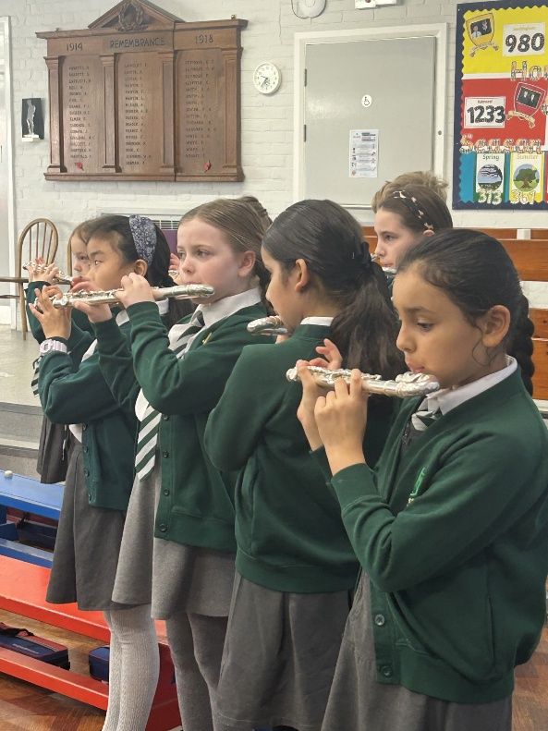
Through our Music curriculum, we aim to engage and inspire pupils to develop a love of music and their talent as musicians, and so increase their self-confidence, creativity and sense of achievement. Children are given regular opportunities for music appreciation sessions and so are able to talk about different pieces of Music from a variety of genres and cultures. Children are able to talk about how different pieces of music make them feel and describe it using the inter related dimensions of music.

During their time at school, the children will have had the opportunity to play a variety of instruments through improvisation and will compose for performances in ensemble arrangements. They will be able to record their composition using non-standard and some standard notation and read simple pieces of Music. Some will have progressed to learning an instrument with a specialist Teacher.
Children in KS2 also visit Wellington Prep school where staff deliver a unit of work.
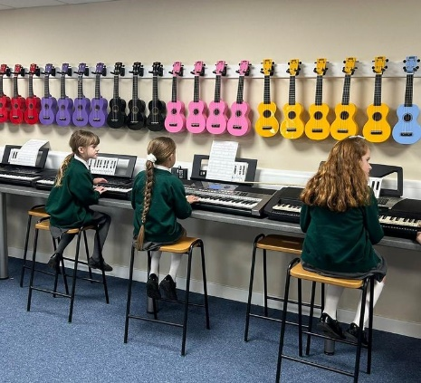

Part B: Extra-curricular music including Music tuition, choirs and ensembles
In KS2 children have the opportunity to join the choir where they will learn songs from a variety of genres and eras as well as having the opportunity to sing in larger choirs with children from other schools. Performances include taking the choir on tour to perform in local venues at Christmas time, performing at Wellington College as part of the Crowthorne Carnival celebrations, and singing in the 'School Junior Music Festival' at the Hexagon Theatre in Reading organised by Berkshire Music Trust. The choir rehearse every week.
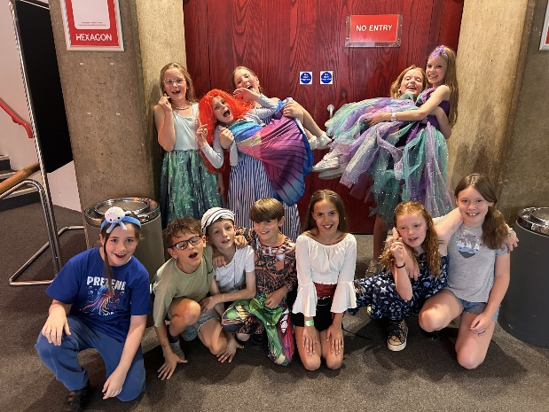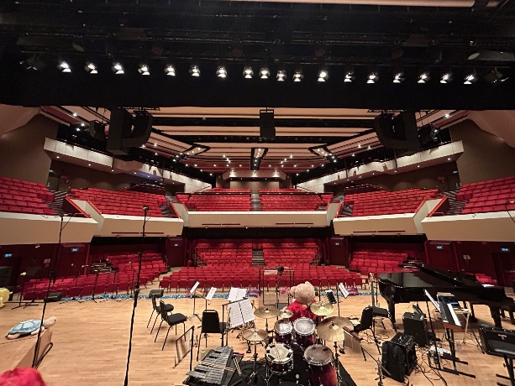
All children access singing in singing assemblies where basic technics are taught. KS1 annually put on a Christmas performance and KS2 put on a production every other year.
Some children, across the school, also participate in Rocksteady sessions, where they get to play instruments, or sing, as part of a band.
Year 4, who have the flute project as part of the time tabled curriculum, have the opportunity to have their flute on free loan for the duration of the project. Extra-curricular opportunities run at the weekends or during holidays (advertised by the Berkshire Music trust) are published to parents via school Newsletter or e-mail and displayed on external doors in school.

Part C: Musical experiences, events and performances
This is about all the other musical events and opportunities that we organise, such as singing in assembly, concerts and shows, and trips to professional concerts.
- Children sing in assembly at least once a week.
- Choir performances in assemblies.
- Class assemblies also provide opportunities to perform for parents (musical ensembles and singing).

November
- Choir performance to parents (not 2026).
- Flute concert to parents and Year 3.

December
- Rocksteady performance to parents and school (children from Year R-6 who have lessons).
- Choir visiting the Mothers Union to perform to members.
- Reception Christmas performance to parents and school.
- KS1 Christmas Performance to parents, school, local pre schools and visitors from local care homes.
- Candle lit Carol Service to parents where all Year groups perform a song (includes a choir performance).
- Service at St Johns church where hymns are sung (parents invited)- includes a performance from the choir.

January
- Young Voices Performance at the O2 (2026).

June
- Choir perform in 'School Junior Music Festival' at the Hexagon Theatre in Reading organised by Berkshire Music Trust.

July
- KS2 production (all children involved from years 3-6)- children have the opportunity to sing solos, duets etc…
- Music Festival at Wellington College where children perform with and to other local schools and their parents and local key figures.
Please note the above events for July are bi-annual

In the future
This is about what the school is planning for subsequent years.
- Consider planning in concert so there is one run each term (recorder concert following Year 3 unit and/or a glockenspiel performance following Year 5 unit).
- Contact Wellington College and local secondary schools to see whether they have a brass assembly (or similar) to come and perform in school.
- Collate registers for who learns an instrument outside of school and what grade they are. Give children more opportunities to perform their instrument to the school.

Further information
The Department for Education publishes a guide for parents and young people on how they can get involved in music in and out of school, and where they can go to for support beyond the school:
https://www.gov.uk/government/publications/music-education-information-for-parents-and-young-people
Berkshire Music Trust Hub:
https://www.berksmusictrust.org.uk/about/berkshire-music-hub/

